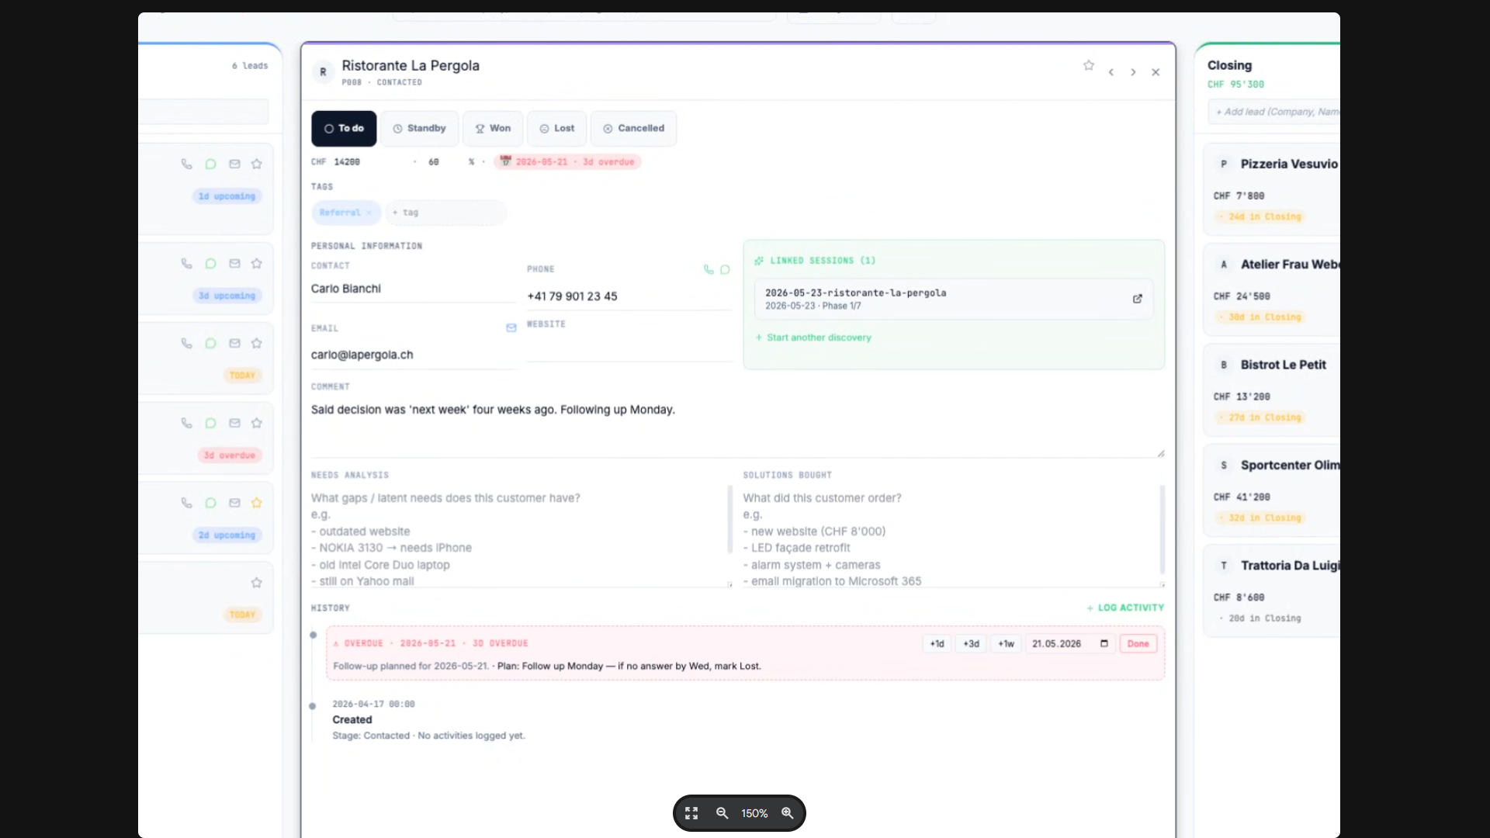

FIELD: COMPANY DETAILS
LABLE:

FIELD: SALES STAGE
LABLE: To Do; Standby; Won; Lost; Cancelled

Collapse Button
FIELD: SALES STAGE
LABLE: To Do; Standby; Won; Lost; Cancelled
FIELD: COMPANY NAME

FIELD: OWNERSHIP LABLE: Sales Agent Nr. 001 - Alias Filippo T.

FIELD: COMPANY DETAILS
LABLES:
a. Company Name: ____________
b. Address: ____________
c. webpage: ____________
d. email: ____________
e. Phone: ____________
f. Whatsapp: ____________
g. Company Registration number: ____________
h. Number of employees: ____________
i. size of company by annual turnover: ____________
j. Decision Maker: ____________
K. all C-suite directors listed by name: ____________
L. name of owner: ____________
Collapse Button

FIELD: COMPANY PEOPLE
LABLES:
a. General Manager/CEO: Mr/Mrs..____________ Phone:____________ Email:_____________
WhatsApp:__________ DOB:______________
Previous Company____________ Spouse:_____________
Children number and Names_______ Car: ___________________
Active in Other Companies ____________________________
His Role in our interactions : __________________ (Decision Maker)

b. Finance& Accounting: Mr/Mrs..____________ Phone:____________ Email:_____________
WhatsApp:__________ DOB:______________
Previous Company____________ Spouse:_____________
Children number and Names_______ Car: ___________________
Active in Other Companies ____________________________
His Role in our interactions : __________________ (Decision Maker ?)

c. IT Manager: : Mr/Mrs..____________ Phone:____________ Email:_____________
WhatsApp:__________ DOB:______________
Previous Company____________ Spouse:_____________
Children number and Names_______ Car: ___________________
Active in Other Companies ____________________________
His Role in our interactions : __________________ (Decision Maker ?)

d. Marketing: ____________

e. Sales: ____________

f. Production: ____________

g. OTHER: ____________

Collapse Button

FIELD: INTERACTIONS
LABLES: (the Interaction reports are sorted Descending from last Date to precious Dates)
Z. Date and Time: Person: Mr/Mrs..____________
Sales_Agent 001: Role: ___CEO________
Interaction via: Phone / Email / WhatsApp/Personally : ____________
What Has been Said: __________________ {content of message}
Documents Sent/Received: {Name and Doc Description}
Production Order: Yes No
Production request: __________________{}

Y. Date and Time: Person: Mr/Mrs..____________
Sales_Agent 001: Role: ___CEO________
Interaction via: Phone / Email / WhatsApp/Personally : ____________
What Has been Said: __________________ {content of message}
Documents Sent/Received: {Name and Doc Description}
Production Order: Yes No
Production request: __________________{}

X. Date and Time: Person: Mr/Mrs..____________
Sales_Agent 001: Role: ___CEO________
Interaction via: Phone / Email / WhatsApp/Personally : ____________
What Has been Said: __________________ {content of message}
Documents Sent/Received: {Name and Doc Description}
Production Order: Yes No
Production request: __________________{}
W. Date and Time: Person: Mr/Mrs..____________
Sales_Agent 001: Role: ___CEO________
Interaction via: Phone / Email / WhatsApp/Personally : ____________
What Has been Said: __________________ {content of message}
Documents Sent/Received: {Name and Doc Description}
Production Order: Yes No
Production request: __________________{}
Change request: __________________{}
Invoice/Payment Request sent to the client. {yes/ no, attached Document} Internal Notes, not to be shared with the client.

Collapse Button

Collapse Button
FIELD: DOCUMENTS SHARED
LABLES:
a. Offer/Work Assignment : ____________
b. Deadline: ____________
c. Production Specifications: ____________
d. Invoice: ____________
e. Payment Recall: ____________
f. Payment Final notice: ____________
g. INKASSO: ____________

Collapse Button
FIELD: CLIENT REQUESTS
LABLES:
a0. REQUEST 001 : ____________
a1. Deadline: ____________
b0. REQUEST 002: ____________
b1. Deadline: ____________

FIELD: CLIENT NEEDS
LABLES:
a0. Need for XXX : ____________
a1. Deadline: ____________
b0. Need XXX: ____________
b1. Deadline: ____________
Collapse Button

